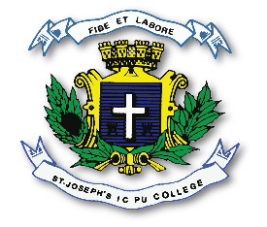
ST. JOSEPH’S INDIAN COMPOSITE PU COLLEGE
#23, Vittal Mallya Road, Bangalore – 560001.

SUBJECT: KANNADA (01)
I PUC
POERTIONS FOR I TEST – 2023-24

